Latest Round-ups:
Season 2019/20
#10
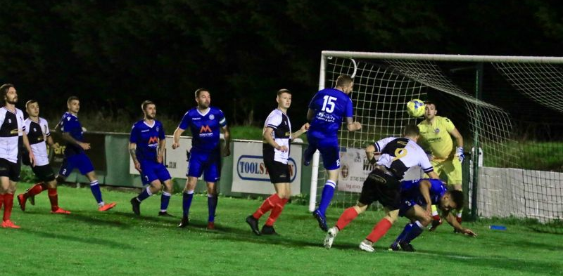
Midweek Action: Shepton Mallet finally suffered their first league defeat of the season on Tuesday, going down by one goal to nil against Bradford Town. In a tight contest between two of the Premier Division highflyers, Gary Higdon’s goal just after the half-hour mark proved vital, with the Bobcat frontman tapping home a powerful cross from Matt Morris. Bitton returned to winning ways in the other Premier Division fixture, holding off a fightback from Brislington to gain a 2-1 home victory. Goals either side of the interval from Josh Egan and Harrison Kyte put Bitton in control of the contest, before visiting skipper Kye Thomas pulled a goal back from long range. Any hope of a Brislington comeback was all-but ended 15 minutes from time, when centre back Danny Barwood was given his marching orders and picking up his second yellow card of the evening. Welton snatched a point away at Devizes in the lone First Division fixture to take place this past midweek, scoring twice in the closing stages to grab a 2-2 draw. The home side had built a strong lead thanks to goals from Matt Russell and Tatenda Majoni before being stunned in the closing stages. Rene Adigbo had given Welton hope when he halved the deficit in the 89th minute, and then in the fourth minute of stoppage time, Adigbo turned provider, nodding the ball down to Chris Pile who drilled the ball home to secure a share of the spoils. In their First Round Somerset Cup tie, two goals at the end of the first half from Steve Murray saw Bridgwater claim a 2-0 victory away at Frome Town.
Action from Bradford Town’s 1-0 victory over Shepton Mallet on Tuesday evening, courtesy of Haydn Jones.
Wednesday evening provided a pair of surprising results in the Premier Division, including Clevedon’s heavy 6-1 defeat at home to Street. The home side were riding a five-game win streak heading into the fixture, but were no match for Street who ran out convincing winners at the Hand Stadium. Visiting skipper Kameron Andrews kept up his fantastic start to the campaign, scoring twice inside the opening hour, adding to goals from Olly Pearson and Olly Hebbard as they built a four-goal lead. Leighton Thomas added a fifth 15 minutes from time, with an own-goal stretching their lead out further before second half sub Nathan Groom struck a late consolation for Clevedon.
There form book was also thrown out the window in south Somerset, where Wellington moved off the bottom of the table thanks to a 3-1 win over Tavistock. Wellington’s attack had been struggling before this game, scoring just six times in eight games, but it came to life on Wednesday, with Conor Bryant’s brace and a Josh Wadham strike putting them three goals ahead at the break. Tavistock pulled a goal back in the second half, but Wellington wouldn’t be denied, and claimed their first home victory this term. Westbury United also secured three points, after a first half goal from Callum Demkiv snuck them past Roman Glass St George by one goal to nil. There were late goals aplenty in the clash between Cadbury Heath and Hallen which eventually finished in a 2-2 tie. Hallen went ahead in first half stoppage time when Matt Davis headed home a fine free-kick from Kyle Thomas, but the story of this game all came down to the final moments. The first of the late strikes from Matt Huxley got Cadbury Heath level two minutes from time, but they were then reduced to ten men to hand their hosts some renewed impetus. Hallen capitalised instantly with Tom Collett putting them back ahead, but Heath had the last word, with a bullet header from Ben Allen in the third minute of stoppage time bringing an end to a breathless encounter.
FA Cup: Tavistock’s excellent run in this season’s FA Cup was brought to an end in the third qualifying round on Saturday afternoon following a 4-1 defeat away at Welling United. A first half hat-trick from Bradley Goldberg put the game to bed at the break, with any chances of a potential fightback from the Lambs derailed by two red cards.
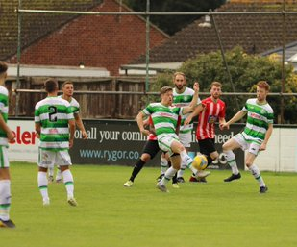
Premier Division: In one of Saturday’s Groundhop fixtures, Bradford Town secured their seventh league victory of the season after beating Clevedon 2-0. The visitors had been in excellent form prior to their midweek setback, but they came unstuck again at Trowbridge Road, after goals in either half from Tyson Pollard fired Bradford to all three points. It is Plymouth Parkway who continue to lead the way at the top of the table following a 5-0 victory away at Hallen. Two goals from leading scorer Adam Carter was bettered slightly by teammate Mikey Williams who fired home a hat-trick during the one-sided contest. Westbury United have now won three on the spin after seeing off Bitton by two goals to one in Wiltshire. After a curled free-kick from Ryan Bole put the home side ahead, Steve Hulbert then provided a cross for Matt Jones to volley home their second towards the end of the first half. Bitton attempted a second half fightback at Meadow Lane but could only strike once thanks to a deflected Mitch Tippins effort, suffering their first away defeat of the season.
Action from Westbury United’s clash with Bitton, courtesy of Martin Pearce.
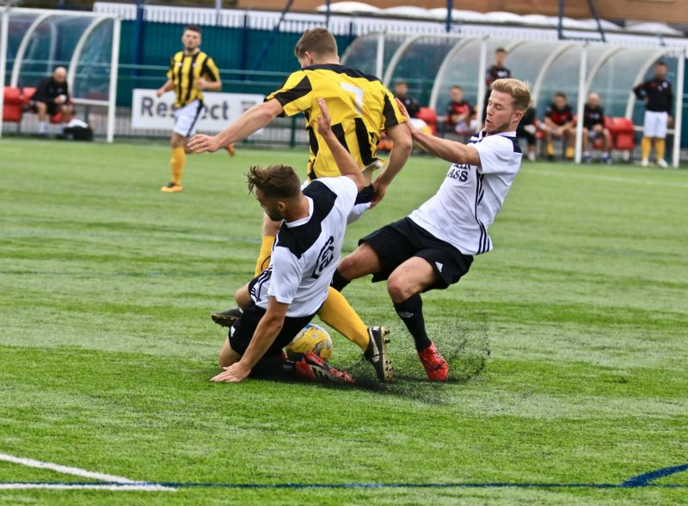
Cribbs snuck past Buckland in their bottom-half clash at the Lawns, with Jason Vincent’s crucial goal midway through the second half leading the home side to a 1-0 victory. Street backed up their big win on Wednesday evening with another fine win on their travels, beating Cadbury Heath 2-1 at Springfield. Following a goalless opening half, Street struck twice in quick succession through Kyle Strange and Olly Pearson to move two goals ahead, before Heath trimmed the deficit thanks to a powerful header from Ben Allen. Roman Glass St George gained just their second league win of the season, beating Shepton Mallet 2-0 at Oaklands Park. Both goals for the hosts came during the second half, with Troy Simpson putting them ahead before Josh Morgan-Williams wrapped up victory later in the game. In an entertaining affair in South Bristol, Chipping Sodbury Town came away with a 4-3 win over Brislington. Having led 3-1 at the interval following goals from Luke Burman, Justin Bishop and Miles Gibson, the Sods let their hosts back into the game following a second half brace from Danny Barwood. Following a long winless run, the Sods finally got back on the winners trail, enjoying their best afternoon in front of goal all season.
Players from Roman Glass and Shepton battle for possession. Image courtesy of Haydn Jones.

On Sunday, Bridgwater enjoyed a big win away at Bridport, with a four-goal first half blitz helping them to eventually claim a 6-0 victory. The opening 45 minutes was one-way traffic for the most part, with Bridgwater striker David O’Hare grabbing a hat-trick for the visitors. Mike Duffy also struck before the interval thanks a lobbed finish, with Sam Towler adding the finishing touches to the victory with two goals in the final ten minutes. Then, in the final game of the weekend, Jordan Harris and Aaron Denney each struck in the first half to give Exmouth Town a 2-0 win away at Wellington.

First Division: The Groundhop’s opening fixture came on Friday evening at Oaklands Park, where Lebeq United defeated Radstock 3-1. Following on from their big victory last weekend, Lebeq made a fine start under the floodlights, going ahead in the ninth minute thanks to a penalty from Cameron Brown. Kurt James then doubled the hosts advantage five minutes later, before Radstock hit back with a penalty of their own from leading scorer James Rustell. Twaine Plummer then restored Lebeq’s two-goal advantage early in the second half, before last week’s hat-trick hero Christian DaCosta was sent off just prior to the hour mark. Radstock were unable to find a way through against the ten men however, with Lebeq holding on to secure back-to-back wins.

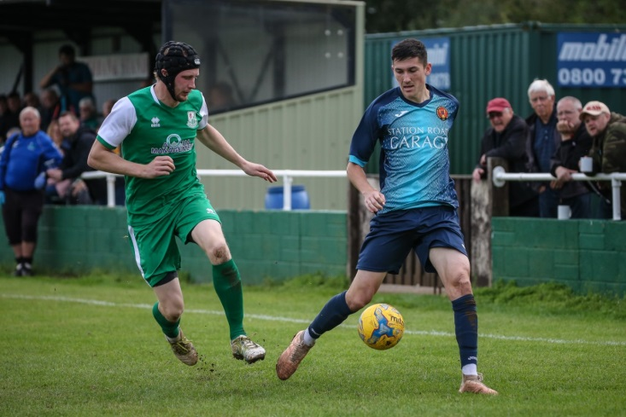
On Saturday, ground-hoppers were treated to an eight-goal thriller at Bristol Road where Portishead Town were beaten 5-3 by Longwell Green Sports. There was only goal in the first half, with Danny Carter firing home a spot kick for Longwell Green, but then the hosts were back on level terms soon after the interval thanks to a penalty of their own from Mitchell Osmond. Carter then restored the visitors lead, with Lovejoy Mafini adding a third, before Osmond’s second penalty of the afternoon brought Portishead back into the contest. The goals continued to fly in during a wild second half, with Sam Crumb and Connor Britton scoring goals four and five for Longwell Green, either side of an effort from Callum Eastwood for the home side. Hengrove can consider themselves among the in-form teams in the division currently after securing a 1-0 victory away at Cheddar. Last season’s runners-up had only lost once coming into this game, but an 83rd minute effort from Regan Burton handed Hengrove all three points as they continue their ascendancy up the table. Ashton & Backwell moved up to sixth after George Jones goal early in the second half handed them a 1-0 victory away at Devizes, while early pacesetters Calne and Oldland battled out a goalless draw at Bremhill View. Wincanton’s topsy-turvy run of form continued at home to Bishop Sutton, with a 41st minute penalty from Dan Wise leading them to a 1-0 victory. Wincanton are joined in the top three by Wells City who battled back from a half-time deficit to draw 1-1 with Bishops Lydeard. A stunning long-range strike from Charlie Wilson had put Lydeard in position to secure victory, but Wells battled back and grabbed a share of the points after Craig Herrod’s cross deflected in to the back of the net off a visiting defender. The unpredictable Corsham Town ended a run of four-straight home defeats in all competitions by beating Welton Rovers 2-0. Town made a strong start to the game, and having already gone close on two occasions, they broke the deadlock after just 11 minutes when Ali Mayoh headed in a Leigh Rogers free-kick. Corsham continued to attack in the opening stages, and after Josh Bright’s effort had come back off the post, Rhys Talmash reacted fastest in the box and rifled home their second of the afternoon. Sherborne Town came back from a goal down at half-time to win 3-1 away at Almondsbury. After Ashley Knight had put the hosts in front, two goals from Alex Murphy and a strike from Anthony Herrin saw Sherborne gain their fifth league victory of the campaign.In the evening fixture, Bristol Telephones gained their first three points of the season thanks to a 3-2 victory away at Warminster Town. After Luke Banfield had fired the Phones ahead after quarter of an hour, two goals in three minutes from Jack Miluk and James Vincent had turned the game in Warminster’s favour at half-time. Dhani Golding then levelled things up three minutes into the second half before Banfield struck for the second time to secure a much-needed victory for the away side.
Action from Corsham Town vs Welton Rovers, courtesy of John Cuthbertson.
Western League Statistical Leaders

PREMIER DIVISION LEADING GOAL SCORERS (League only):
Adam Carter (Plymouth Parkway) – 16
Jack Taylor (Bridgwater Town) – 9
Jack Fillingham (Shepton Mallet) – 9
Lucas Vowles (Clevedon Town) – 9
Josh Egan (Bitton) – 9

PREMIER DIVISION TOP ATTENDANCES:
Bridport 0 Bridgwater Town 6, Sunday 6th October 2019 – 347
Wellington 0 Exmouth Town 2, Sunday 6th October 2019 - 315
Plymouth Parkway 1 Exmouth Town 0, Wednesday 21st August 2019 - 308

FIRST DIVISION LEADING GOAL SCORERS (League only):
James Rustell (Radstock Town) – 11
Harry Foster (Wells City) – 9
Stuart Windsor (Calne Town) – 9
Adam Wright (Cheddar) – 7

FIRST DIVISION TOP ATTENDANCES:
Warminster Town 2 Bristol Telephones 3, Saturday 5th October - 369
Portishead Town 3 Longwell Green Sports 5, Saturday 5th October – 262
Devizes Town 0 Ashton & Backwell United 1, Saturday 5th October – 252

LEADING SCORERS IN ALL COMPETITIONS:
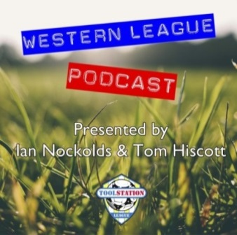
Jack Crago (Tavistock) - 17
Adam Carter (Plymouth Parkway) – 16
James Rustell (Radstock Town) – 15
Harry Foster (Wells City) – 12
Jack Taylor (Bridgwater Town) - 12
Jack Fillingham (Shepton Mallet) – 12
Stuart Windsor (Calne Town) – 10
Lucas Vowles (Clevedon Town) – 10
Gary Higdon (Bradford Town) – 10

Be sure to check out the latest podcast, where Ian, Tom & guests recap all the latest news and results from around the Western League. To follow along all season, each broadcast will be available at the following link: http://www.toolstationleague.com/podcasts.php

*All goalscoring stats via
Full-Time FA website

Latest Results
Tuesday 1st October 2019
Premier Division
Bitton 2-1 Brislington 82
Shepton Mallet 0-1 Bradford Town 142
First Division
Devizes Town 2-2 Welton Rovers 48
Somerset FA Premier Cup – First Round
Frome Town 0-2 Bridgwater Town
Wednesday 2nd October 2019
Premier Division
Cadbury Heath 2-2 Hallen 45
Clevedon Town 1-6 Street 96
Roman Glass St George 0-1 Westbury United 50
Wellington 3-1 Tavistock 101
Friday 4th October 2019
First Division
Lebeq United 3-1 Radstock Town 192
Saturday 5th October 2019
FA Cup – Third Qualifying Round
Welling United 4-1 Tavistock 491
Premier Division
Bradford Town 2-0 Clevedon Town 228
Brislington 3-4 Chipping Sodbury Town
Cadbury Heath 1-2 Street 55
Cribbs 1-0 Buckland Athletic 55
Hallen 0-5 Plymouth Parkway 68
Roman Glass St George 2-0 Shepton Mallet 50
Westbury United 2-1 Bitton 75
First Division
Almondsbury 1-3 Sherborne Town 27
Calne Town 0-0 Oldland Abbotonians 74
Cheddar 0-1 Hengrove Athletic 60
Corsham Town 2-0 Welton Rovers 76
Devizes Town 0-1 Ashton & Backwell United 252
Portishead Town 3-5 Longwell Green Sports 262
Warminster Town 2-3 Bristol Telephones 369
Wells City 1-1 Bishops Lydeard 50
Wincanton Town 1-0 Bishop Sutton 36
Sunday 6th October 2019
Premier Division
Bridport 0-6 Bridgwater Town 347
Wellington 0-2 Exmouth Town 315

*Games in italics signify that they were part of the Groundhop Weekend

Upcoming Fixtures
Tuesday 8th October 2019
Premier Division
Hallen vs Tavistock 19:30KO
Somerset FA Premier Cup – First Round
Odd Down vs Paulton Rovers 19:45KO
Radstock Town vs Portishead Town 19:30KO
Shepton Mallet vs Bath City 19:30KO
Welton Rovers vs Brislington 19:30KO
Wiltshire FA Senior Cup – First Round
Devizes Town vs Purton 19:45KO
Wednesday 9th October 2019
Somerset FA Premier Cup – First Round
Clevedon Town vs Keynsham Town 19:45KO
Larkhall Athletic vs Street 19:45KO
Wellington vs Wells City 19:45KO
Wiltshire FA Senior Cup – First Round
Westbury United vs Royal Wootton Bassett 19:45KO
Saturday 12th October 2019 (KICK OFF AT 3.00PM UNLESS NOTED)
FA Vase – First Round
Bitton vs Tadley Calleva
Bradford Town vs Lymington Town
Camelford vs Buckland Athletic
Exmouth Town vs Portland United
Malmesbury Victoria vs Roman Glass St George
Newport (IoW) vs Bridgwater Town
Romsey Town vs Plymouth Parkway
Tavistock vs Shepton Mallet
Warminster Town vs East Cowes Victoria Athletic
Westbury United vs Badshot Lea
Premier Division
Brislington vs Bridport
Cadbury Heath vs Chipping Sodbury Town
Clevedon Town vs Hallen
Street vs Cribbs
Wellington vs Odd Down
First Division
Ashton & Backwell United vs Corsham Town
Bristol Telephones vs Almondsbury
Calne Town vs Wells City
Devizes Town vs Bishop Sutton
Hengrove Athletic vs Sherborne Town
Longwell Green Sports vs Wincanton Town
Oldland Abbotonians vs Portishead Town
Radstock Town vs Cheddar
Welton Rovers vs Lebeq United

League Tables
Premier Division
 |  | P | W | D | L | F | A | GD | PTS
1 | Plymouth Parkway | 9 | 7 | 1 | 1 | 39 | 7 | 32 | 22
2 | Bradford Town | 8 | 7 | 0 | 1 | 20 | 9 | 11 | 21
3 | Bridgwater Town | 9 | 6 | 2 | 1 | 32 | 11 | 21 | 20
4 | Westbury United | 9 | 5 | 1 | 3 | 19 | 15 | 4 | 16
5 | Clevedon Town | 9 | 5 | 1 | 3 | 21 | 21 | 0 | 16
6 | Bitton | 8 | 5 | 0 | 3 | 25 | 12 | 13 | 15
7 | Exmouth Town | 6 | 5 | 0 | 1 | 13 | 2 | 11 | 15
8 | Street | 8 | 5 | 0 | 3 | 19 | 15 | 4 | 15
9 | Shepton Mallet | 7 | 4 | 1 | 2 | 17 | 10 | 7 | 13
10 | Hallen | 8 | 4 | 1 | 3 | 16 | 20 | -4 | 13
11 | Brislington | 10 | 4 | 0 | 6 | 17 | 26 | -9 | 12
12 | Cribbs | 9 | 3 | 1 | 5 | 9 | 19 | -10 | 10
13 | Odd Down | 10 | 3 | 1 | 6 | 13 | 24 | -11 | 10
14 | Tavistock | 5 | 3 | 0 | 2 | 15 | 10 | 5 | 9
15 | Buckland Athletic | 8 | 3 | 0 | 5 | 12 | 17 | -5 | 9
16 | Cadbury Heath | 10 | 2 | 3 | 5 | 14 | 23 | -9 | 9
17 | Keynsham Town | 8 | 2 | 2 | 4 | 18 | 22 | -4 | 8
18 | Bridport | 10 | 2 | 1 | 7 | 16 | 32 | -16 | 7
19 | Chipping Sodbury Town | 10 | 2 | 1 | 7 | 11 | 34 | -23 | 7
20 | Roman Glass St George | 7 | 2 | 0 | 5 | 13 | 9 | 4 | 6
21 | Wellington | 10 | 2 | 0 | 8 | 9 | 30 | -21 | 6

First Division
 |  | P | W | D | L | F | A | GD | PTS
1 | Calne Town | 9 | 5 | 2 | 2 | 14 | 5 | 9 | 17
2 | Wincanton Town | 8 | 5 | 2 | 1 | 19 | 12 | 7 | 17
3 | Wells City | 8 | 5 | 1 | 2 | 22 | 12 | 10 | 16
4 | Oldland Abbotonians | 10 | 4 | 4 | 2 | 9 | 9 | 0 | 16
5 | Cheddar | 7 | 5 | 0 | 2 | 16 | 10 | 6 | 15
6 | Ashton & Backwell United | 8 | 4 | 3 | 1 | 11 | 8 | 3 | 15
7 | Sherborne Town | 8 | 5 | 0 | 3 | 16 | 15 | 1 | 15
8 | Longwell Green Sports | 8 | 4 | 1 | 3 | 17 | 15 | 2 | 13
9 | Portishead Town | 8 | 4 | 0 | 4 | 22 | 18 | 4 | 12
10 | Radstock Town | 8 | 4 | 0 | 4 | 20 | 17 | 3 | 12
11 | Lebeq United | 8 | 4 | 0 | 4 | 17 | 18 | -1 | 12
12 | Corsham Town | 9 | 4 | 0 | 5 | 15 | 27 | -12 | 12
13 | Bishops Lydeard | 8 | 3 | 1 | 4 | 16 | 12 | 4 | 10
14 | Almondsbury | 8 | 3 | 1 | 4 | 13 | 13 | 0 | 10
15 | Warminster Town | 8 | 3 | 0 | 5 | 17 | 14 | 3 | 9
16 | Hengrove Athletic | 9 | 2 | 3 | 4 | 6 | 23 | -17 | 9
17 | Devizes Town | 8 | 2 | 2 | 4 | 18 | 18 | 0 | 8
18 | Welton Rovers | 8 | 2 | 1 | 5 | 8 | 17 | -9 | 7
19 | Bishop Sutton | 8 | 2 | 0 | 6 | 11 | 16 | -5 | 6
20 | Bristol Telephones | 8 | 1 | 1 | 6 | 12 | 20 | -8 | 4

